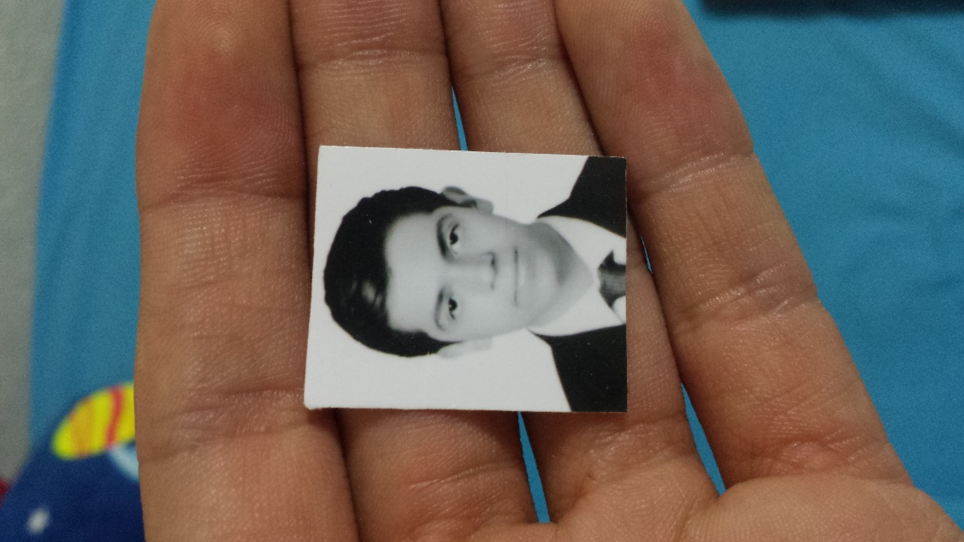

Priv. Aquiles Serdán #7, Centro, 38600, Acámbaro, Guanajuato

**Years:** 21 years

**Date of Birth:** 07/04/1996

**Curp:** MABM960407HGTNRG04

**Phone Number:** 17-2-71-05, 417-100-92-87

**E-mail:** MiguelMandujano97@hotmail.com

**Civil Status:** Single

**Nationality:** mexican

**Professional License:** 8821914

**Miguel Ángel Mandujano Barragán**

*Técnico Superior Universitario /Tecnologías de la información y comunicación*



**Academic Unit of the southeast, Campus Acámbaro**

**EDUCATION**



*Técnico Superior Universitario, Tecnologías de la información y comunicación*

*20015 - 2017*

**Complementary education**

*Certificate of Microsoft Word 2012*

**EXPERIENCE**



**Employee**

**Deportes Rafael |**

*2015 - 2017*

Counter salesman with high levels of sales convincing and professional inventory management.

Develop my informatics and creative skills acquired throughout my career as a TSU to offer an excellent job as a developer and designer besides promoting a good work environment to all my co-workers, guiding them to success and knowledge.

**OBJETIVES**



Spanish languaje as a native languaje, basic English languaje handling in a 50%.

Ability to create software in JAVA languaje and web sites with HTML5 management, CSS3, PHP and BOOTSTRAP in addition to basic principles of Javascript and codeigniter.

High knowledge of CMS wordpress.

Management of photo design software and video editing, with high knowledge in the library of ADOBE.

Conference attendance SWITCH 2016 in Leon Guanajuato, inside entrepreneurship workshops.



**SKILLS AND KNOWLEDGES**

**Name:** Rogelio Almanza Herrejon

**Phone Number:** 17-2-26-26

**Address:** Francisco I. Madero #1066 Street

**Email:** spice_rah@hotmail.com

**Relationship:** Coworker

**Years of knowing him:** 2 years

**Name:** Mary Carmen Crescencio Bernal

**Phone number:** 417-104-97-74

**Address:** Niño artillero #30 Street

**Email:** marylupe58@hotmail.com

**Relationship:** Coworker

**Years of knowing him:** 6 years



**PERSONAL REFERENCES**

**Empresa**

*Mayo de 2010 - Presente*